Q1.Write a program to display names of 5 subject on each line.

Q2.Write a program to show use of static initialization of int, float, char , string and Boolean values.

Q3.Write a program to use a variable with dynamic initialization check and display its type and value by entering different values.

Q4.Write a program to get input of a number .calculate & display its square , sq. root and cube.

Q5.Write a program to get input of one integer & one float value and display all 6 arithmetic operation.

Q6.Write a program to get input of number calculate and display its square ,sq. root and cube.

Q7. Write a program to get input of 3 elements & 3 values display one key only values and also show all elements .

Q8. Write a program to get input of a string of at least 8 chars & show the result of following operation

1. Display whole the string
2. Display only 2nd ,3rd ,5th ,7th char(not index)
3. Display only 1st ,3rd,5th & 8th char (not index)
4. Display a substring from 3rd to 6th char

Q9 Write a program to create a list of 6 different elements & show following slicing operation

1. to all elements
2. 2 to 4 elements
3. 3rd to all element
4. iv . 4 to all elements

Q10.Write any python program using con catenation

Q11 Write a program to get input of one integer value , float , char , string and display all this value using format char

Q12. Write a program to get input of 2 number display original and swapped values

Q13. Write a program to get input of one number check and display is it odd or even

Q14. Write a program to get input of maxmarks , obtmarks calculate average marks show result “PASS ” when avrg marks>=40 else “FAIL”.

Q15. Write a program to get input of 3 test marks (out of 20) calculate total avrg marks and show the grade as

Avrg Grade

<10 C

10-<14 B

14<18 A

18-20 A+

Q16. Write a program to display Hello msg 5 times

Q17 Write a program to display 1 to 10 numeric series

Q18 Write a program to get input of string count number vowels in it

Q19. Write a program to get input of string & char find & show the frequency of character in string.

Q20. Write a program to show 1-100 series but skip even number between 50-60.

Q21. Write a program to get input of integer in list repeatedly but as soon as value is grater than 100 stop input & display all values

Q22. Write a program to display execute a loop between 1-10 but when the loop counter 5 exit the loop

Q23 Write a program to get input of integer in list reputedly but as soon as value enlesses is greater than input & display all values.

Q24.Write a program to show different string operation.

Q25. Write a program to use different string slicing operation

Q26. Write a program to show function with multiple parameters.

Q27. Write a program function with multiple parameters.

Q28. Write a program using function with single return function can return value to its calling statement using return keywords.

Q29. Write a program to create following class

Q30. Write a program to create following class “Number”

Data member 🡪n ,m

Function member 🡪i. getInput()

ii.Showmin🡪show smallest of n& m

iii.showmax🡪show highest of n & m

Q31 Write a program using constructor

Q32. Write a program use of Destructor

Q33. Write a program of use of Single Inheritance

Q34. Write a program of use of Multi-level Inheritance

Q35. Write a program of Multiple Inheritance

Q36. Write a program of Hierarchical Inheritance

Q37.Write a python program for following:

Enter A Number

**ok**

Square

Q38. Write a python program for following gui radiobutton :

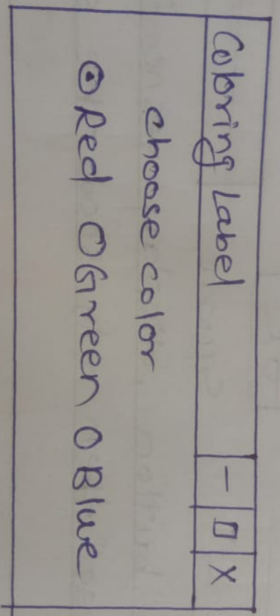

Q39.Write a python program for following gui checkbutton:

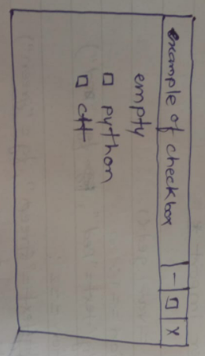

Q40.Read all records and calculate and display tot marks and avrg marks of each record.

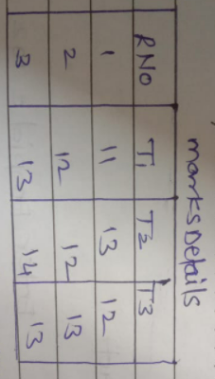

Q41.Write a python program for inserting record in Database table.

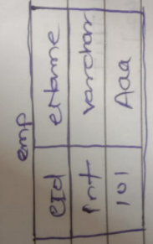

Q42.Write a python program for updating record in above table.

Q43.Write a python program for deleting record in above table.

Q44.get input of billno, pname, rate & qty calculate amt, tax(3.9%), save the all the records in below table, show all the recoreds.

BillDetails

|  |  |  |  |  |  |
| --- | --- | --- | --- | --- | --- |
| Billno | pname | Rate | Qty | Amount | tax |
|  |  |  |  |  |  |